

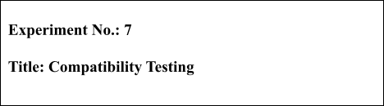



**Batch: B1 Roll No.: 16010421119 Experiment No.: 7 Aim:** To perform compatibility testing using any open source tool

**Resources needed:** Internet

# Theory:

Compatibility Testing is a type of Software testing to check whether your software is capable of running on different hardware, operating systems, applications, network environments or [Mobile](https://www.guru99.com/mobile-testing.html) devices.

# Types of Compatibility Tests:

**Hardware:** It checks software to be compatible with different hardware configurations.

**Operating Systems:** It checks your software to be compatible with different Operating Systems like Windows, Unix, Mac OS etc.

**Software:** It checks your developed software to be compatible with other softwares. For example: MS Word application should be compatible with other software like MS Outlook, MS Excel, etc.

**Network:** Evaluation of performance of system in a network with varying parameters such as Bandwidth, Operating speed, Capacity. It also checks application in different networks with all parameters mentioned earlier.

**Browser:** It checks compatibility of your website with different browsers like Firefox, Google Chrome and Internet Explorer etc.

**Devices:** It checks compatibility of your software with different devices like USB port Devices, Printers and Scanners, Other media devices and Bluetooth.

**Mobile:** Checking your software is compatible with mobile platforms like Android , iOS etc.

**Versions of the software:** It is verifying software application to be compatible with different versions of software.

The most important use of compatibility testing is to ensure whether developed software works under different configurations (as stated in requirements documentation). This testing is necessary to check whether the application is compatible with client's environment.

Following are the tools which are useful in compatibility testing:

* CrossBrowserTesting
* LambdaTest
* Sauce Labs
* Endtest

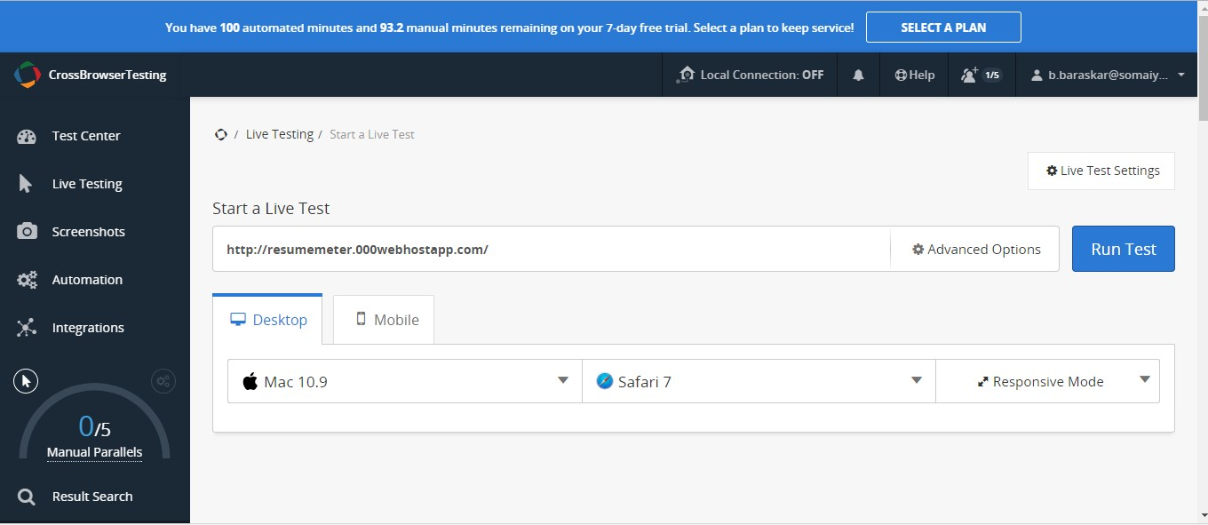

CrossBrowserTesting Tool

# Procedure:

1. Explore any one tool for compatibility testing.
2. Perform compatibility testing of any website.
3. Execute any three features of the tool.

# Results: Snapshots of test results and script

4.

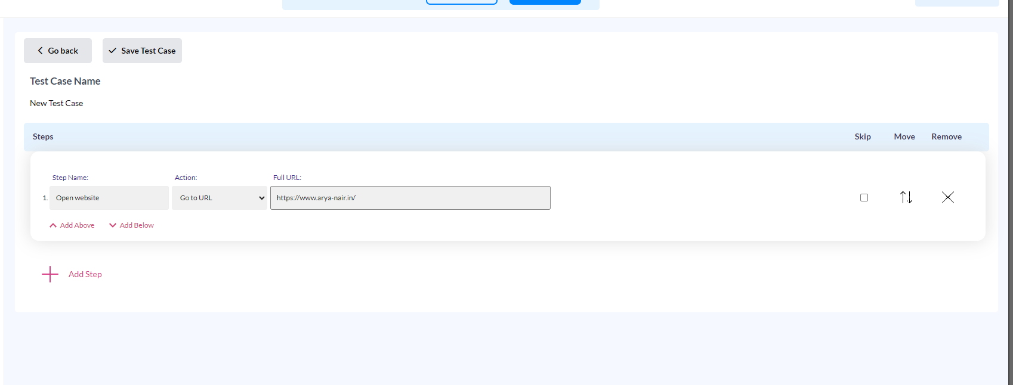

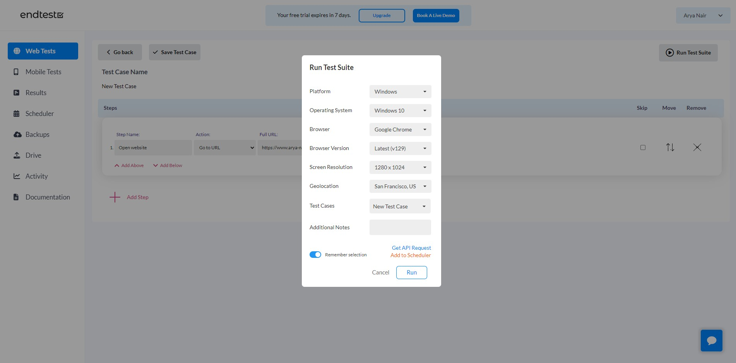

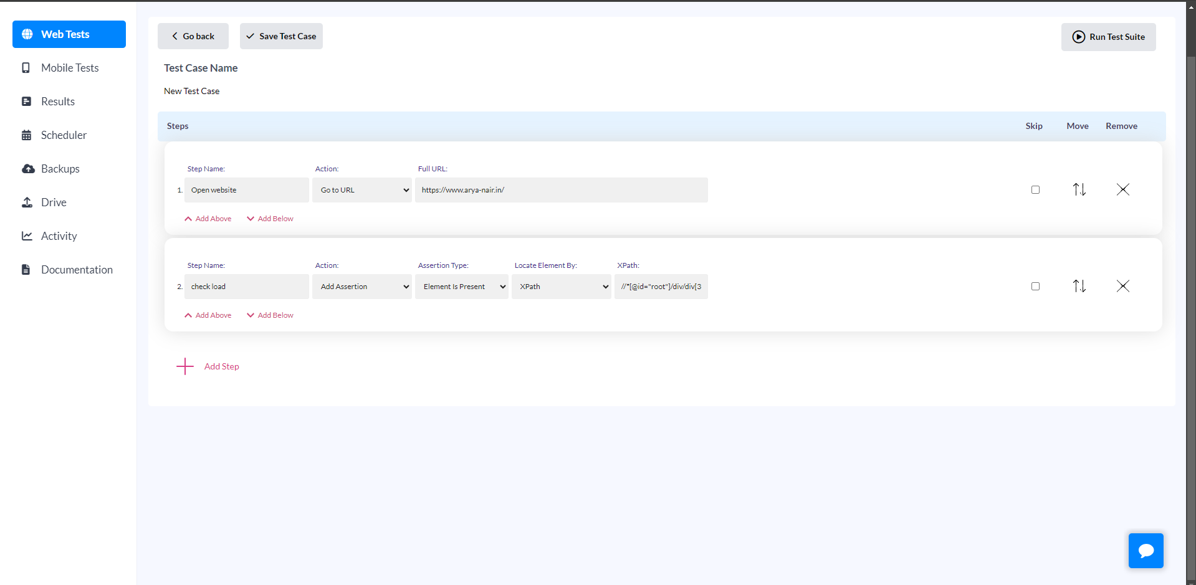

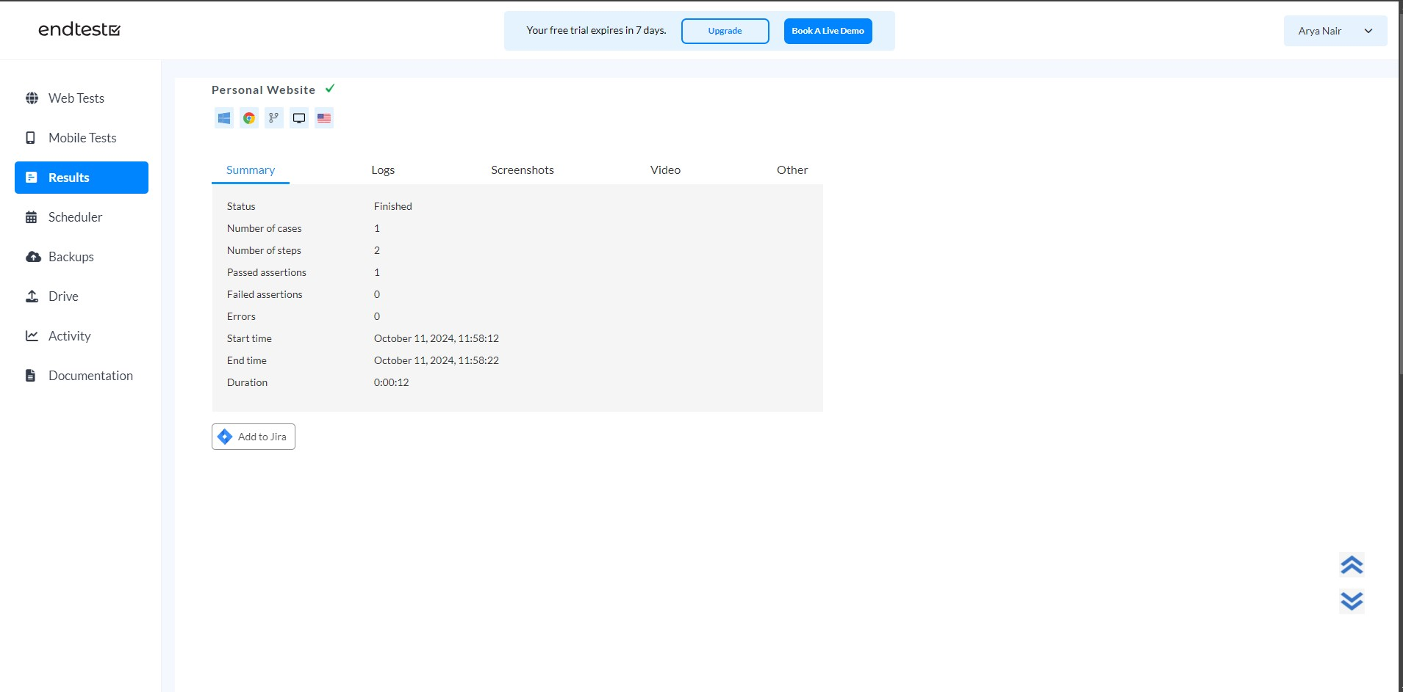

Sauce labs

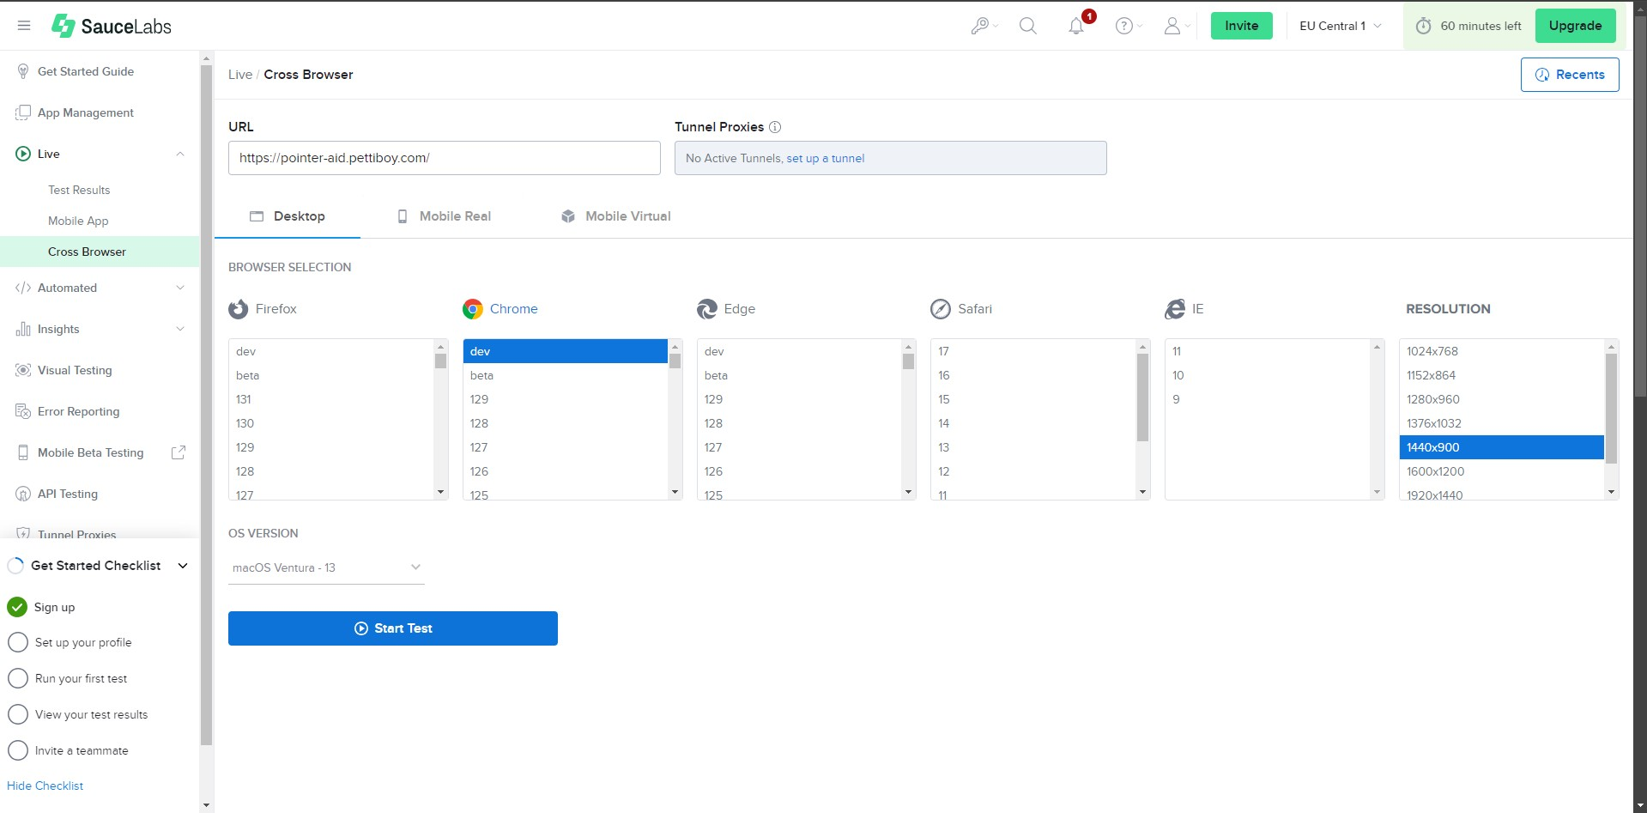

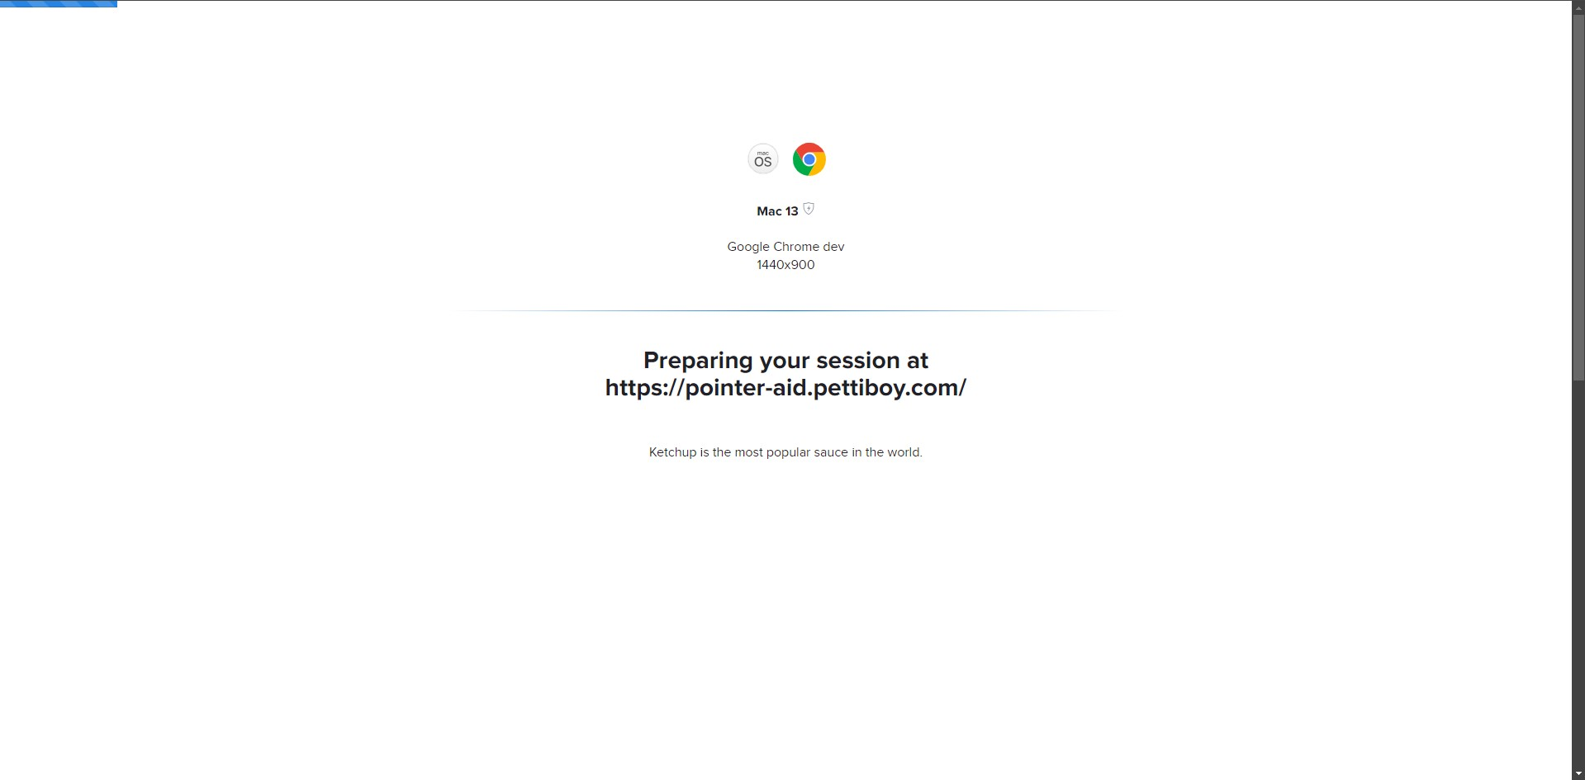

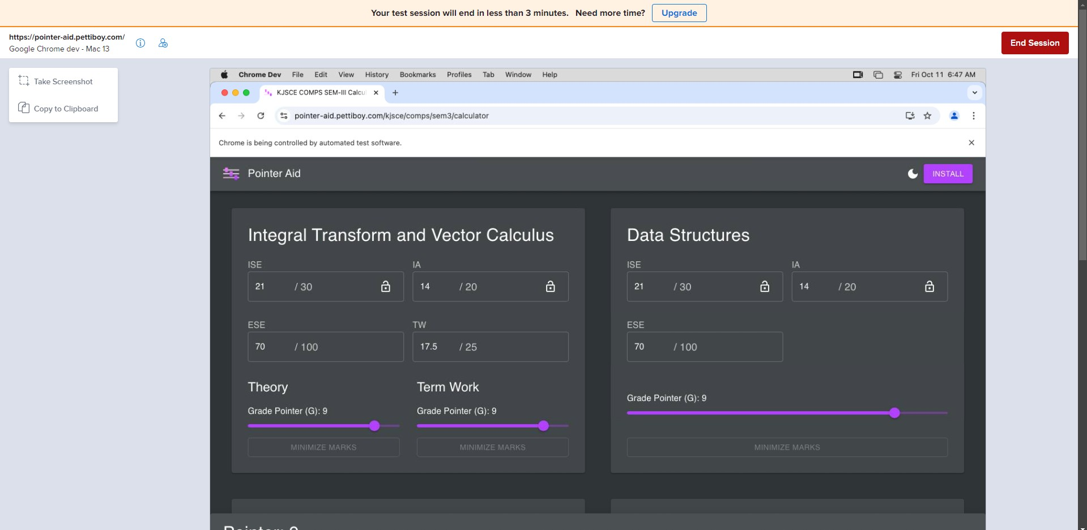

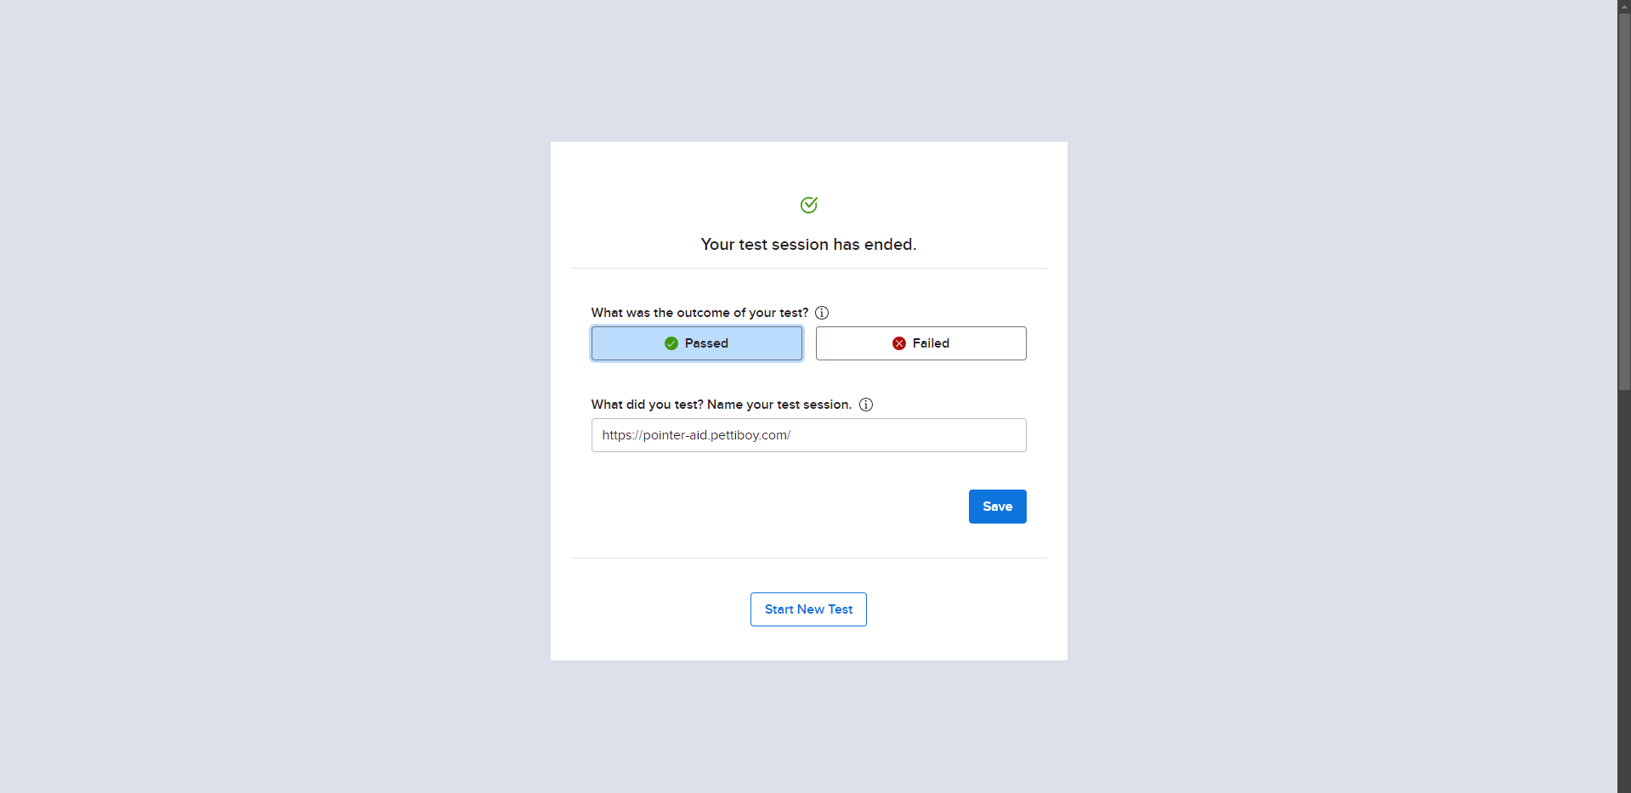

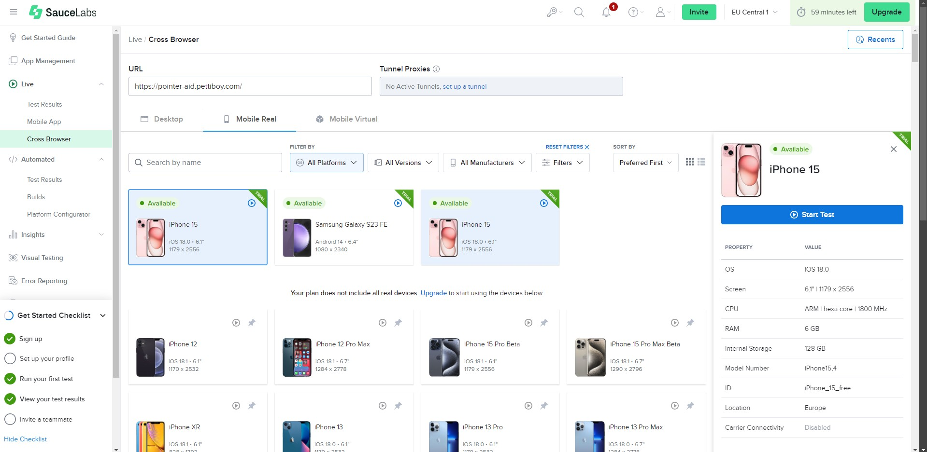

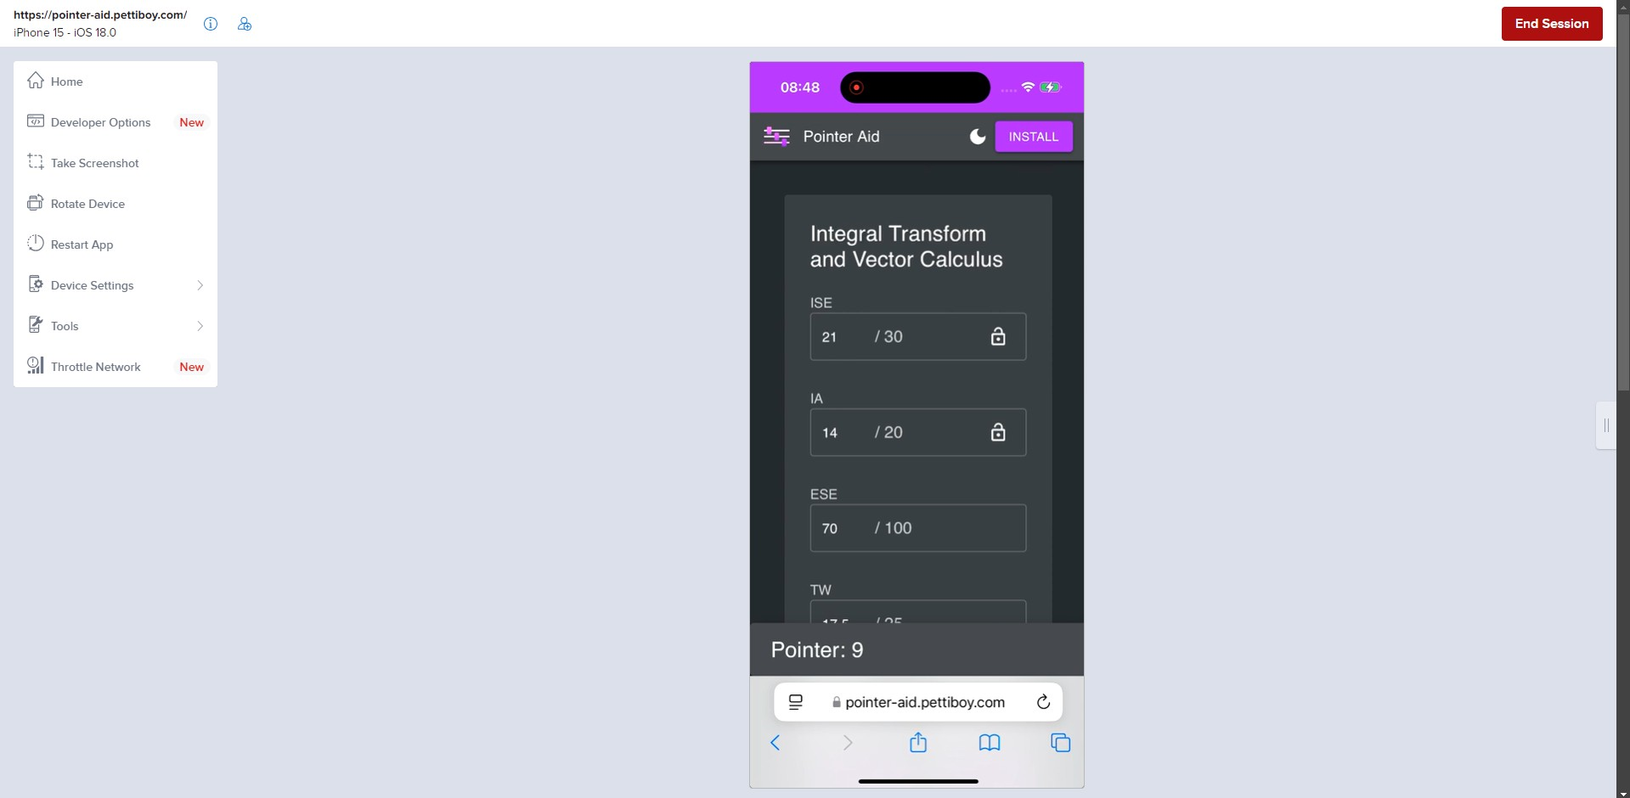

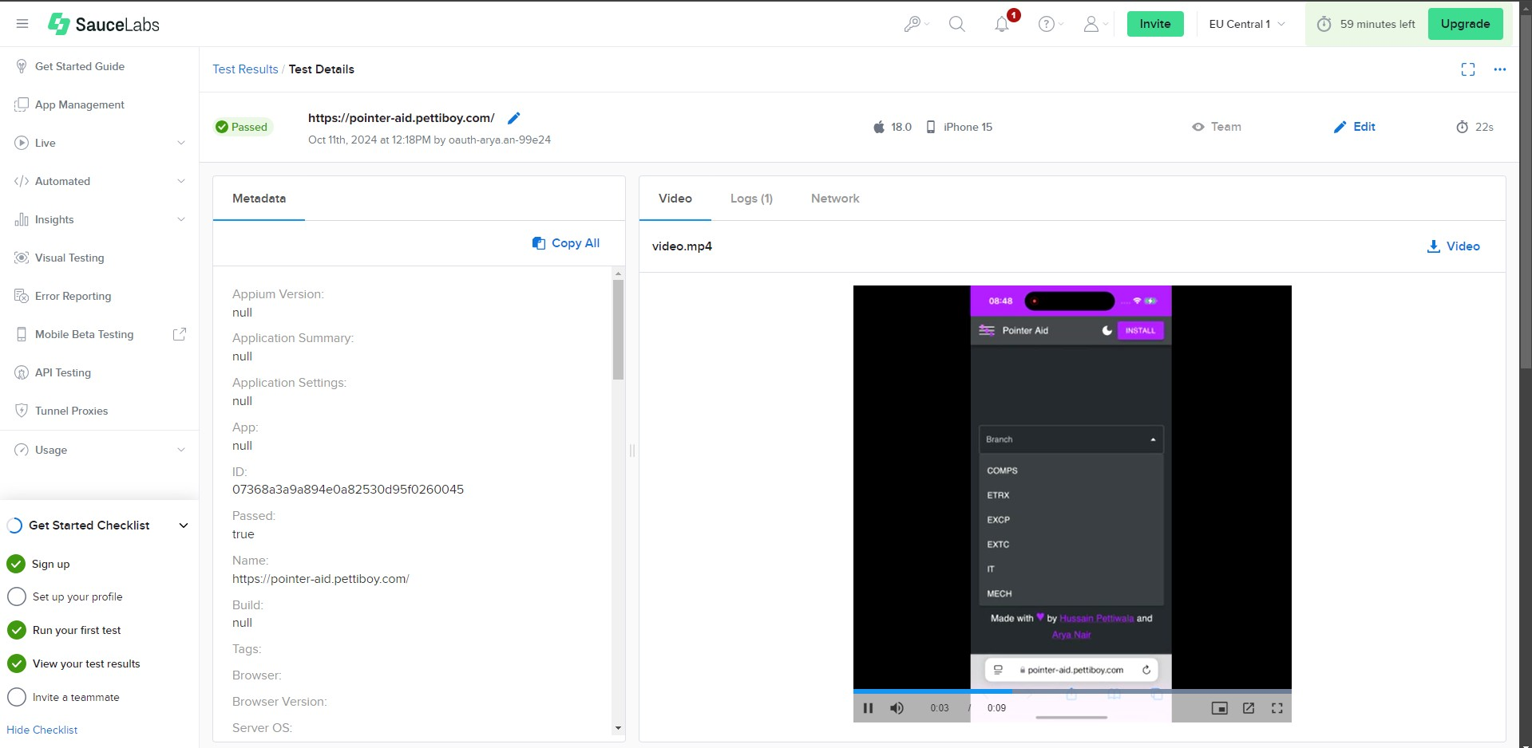

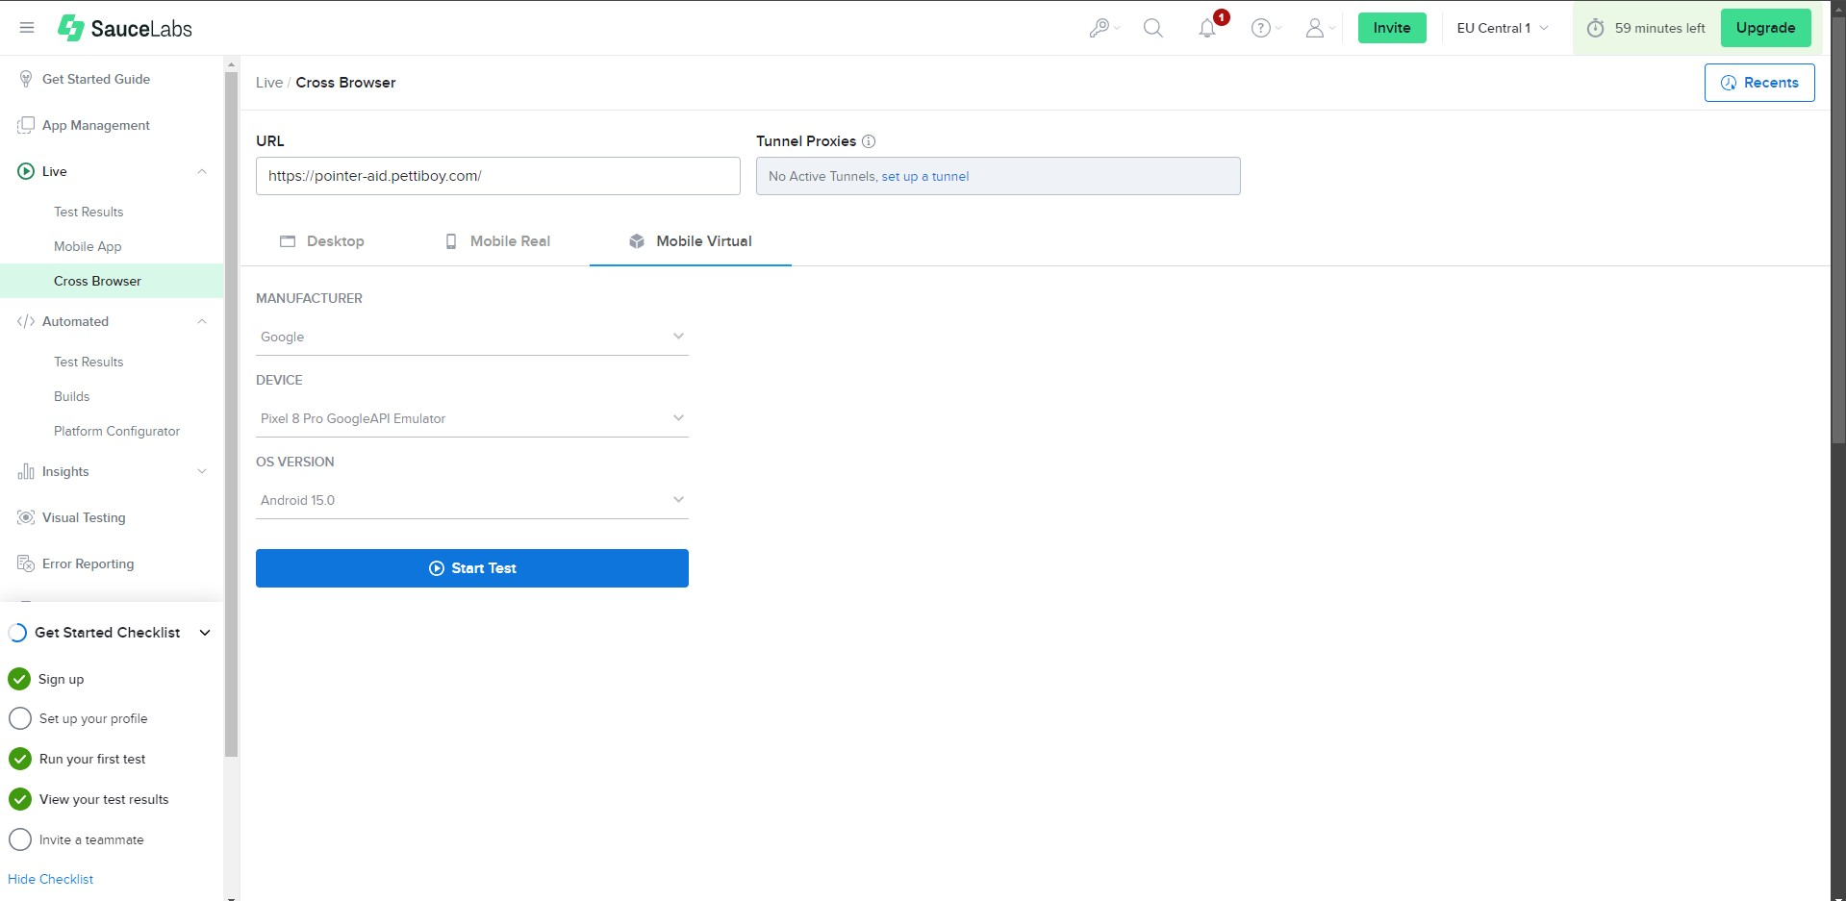

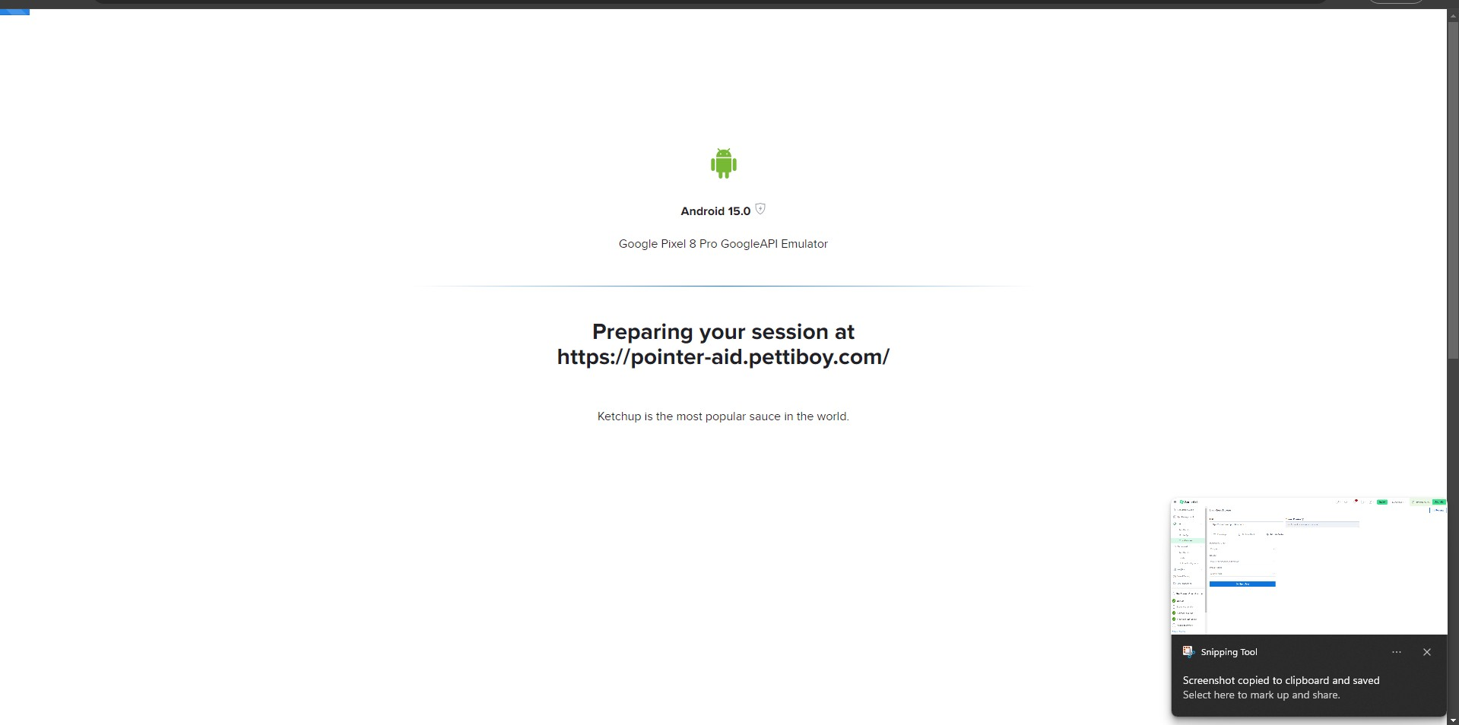

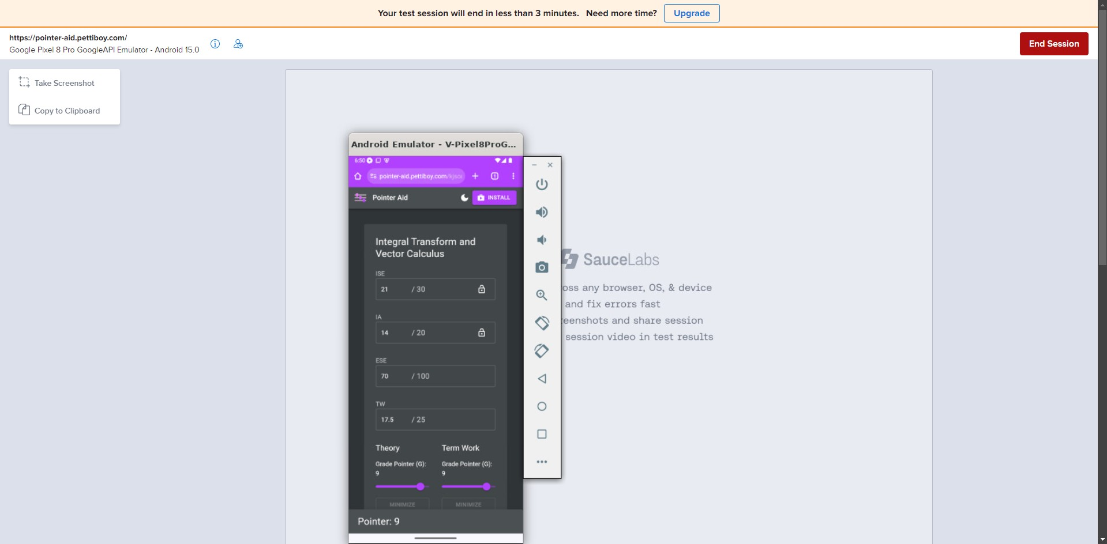

# Questions:

1. **Explain backward and forward Compatibility Testing.**

Ans:Backward compatibility testing ensures that newer versions of a software application can still operate with older versions, verifying that new features or updates do not disrupt existing functionalities. This type of testing is essential for maintaining user accessibility, as it confirms that users with older versions can still utilize critical features without issues. For instance, when a new version of a web browser is released, backward compatibility testing checks that websites designed



for the previous version still function correctly.

On the other hand, forward compatibility testing ensures that older versions of an application can operate with newer versions. This involves verifying that outdated software can handle data or functionalities from newer versions without failure, thus maintaining a seamless user experience. For example, an older version of an application may need to open files created with a newer version; forward compatibility testing ensures that this process occurs smoothly.

Together, backward and forward compatibility testing play vital roles in ensuring smooth

transitions between software versions, preventing disruptions in user experience, and maintaining continuity in software operations.

# Outcomes: CO3 Apply recent automation tools for testing software.

**Conclusion: (Conclusion to be based on outcomes) Performed compatibility testing using endtest**

# Grade: AA / AB / BB / BC / CC / CD /DD Signature of faculty in-charge with date

**Reference Websites:**

* 1. https://app.crossbrowsertesting.com
  2. <https://www.softwaretestinghelp.com/how-is-cross-browser-testing-performed/>
  3. <https://endtest.io/tests>
  4. [https://www.lambdatest.com/](http://www.lambdatest.com/)
  5. https://experitest.com